# LAB 8 Scene Transition

Demo

<https://drive.google.com/file/d/1ysVFUmpgSHKbJaMC73MLNsbOqVqdSK5t/view?usp=sharing>

Create two scenes add them to build profile

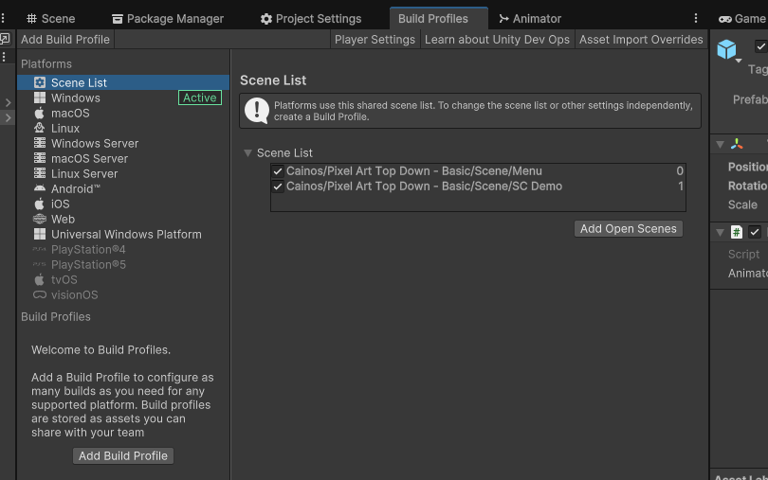

Create a Level Loader and make sure it is in both scenes/levels

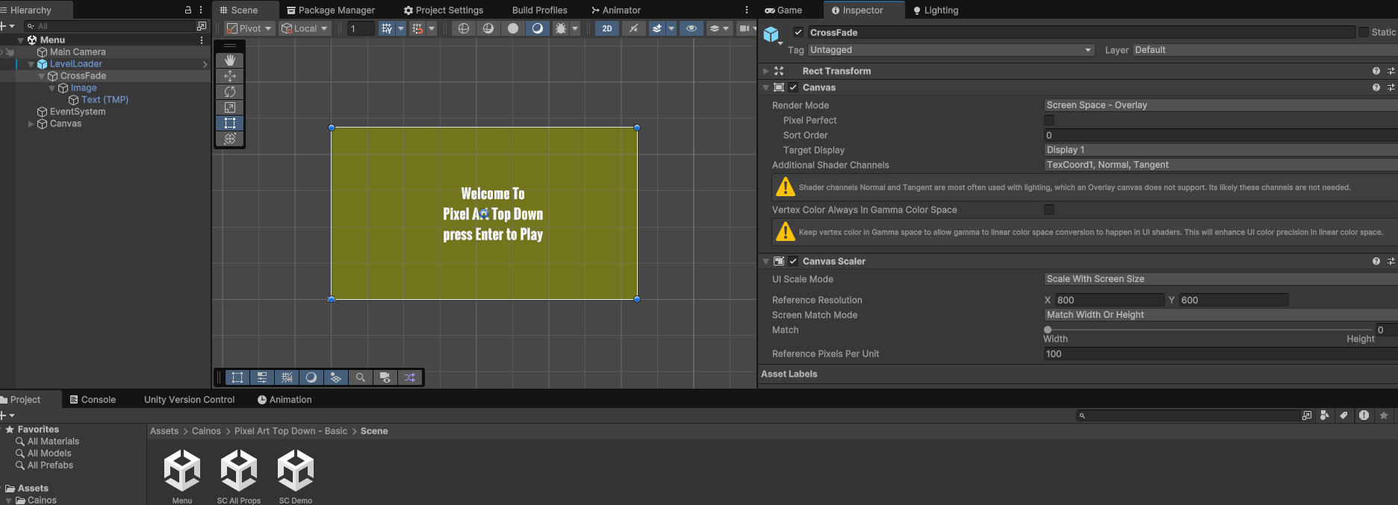

Create a LevelLoader script to transition the scenes

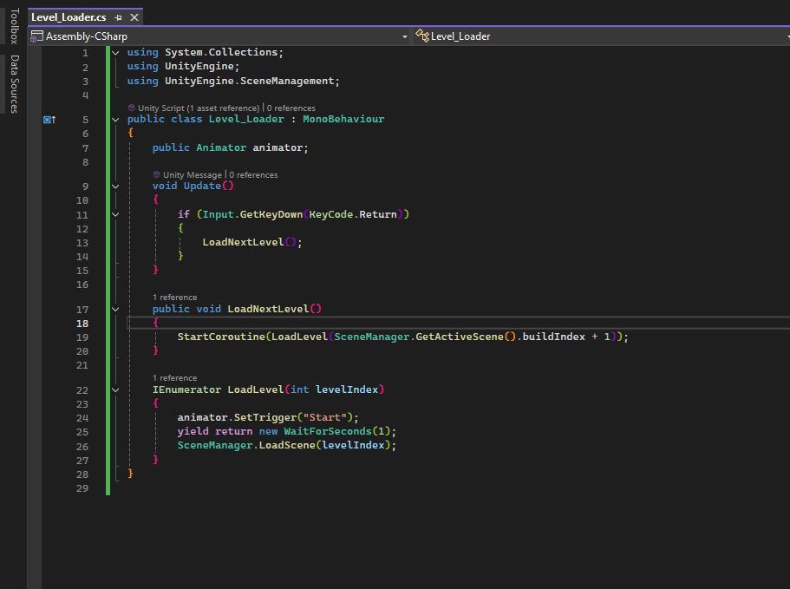

Create Scene Tansition

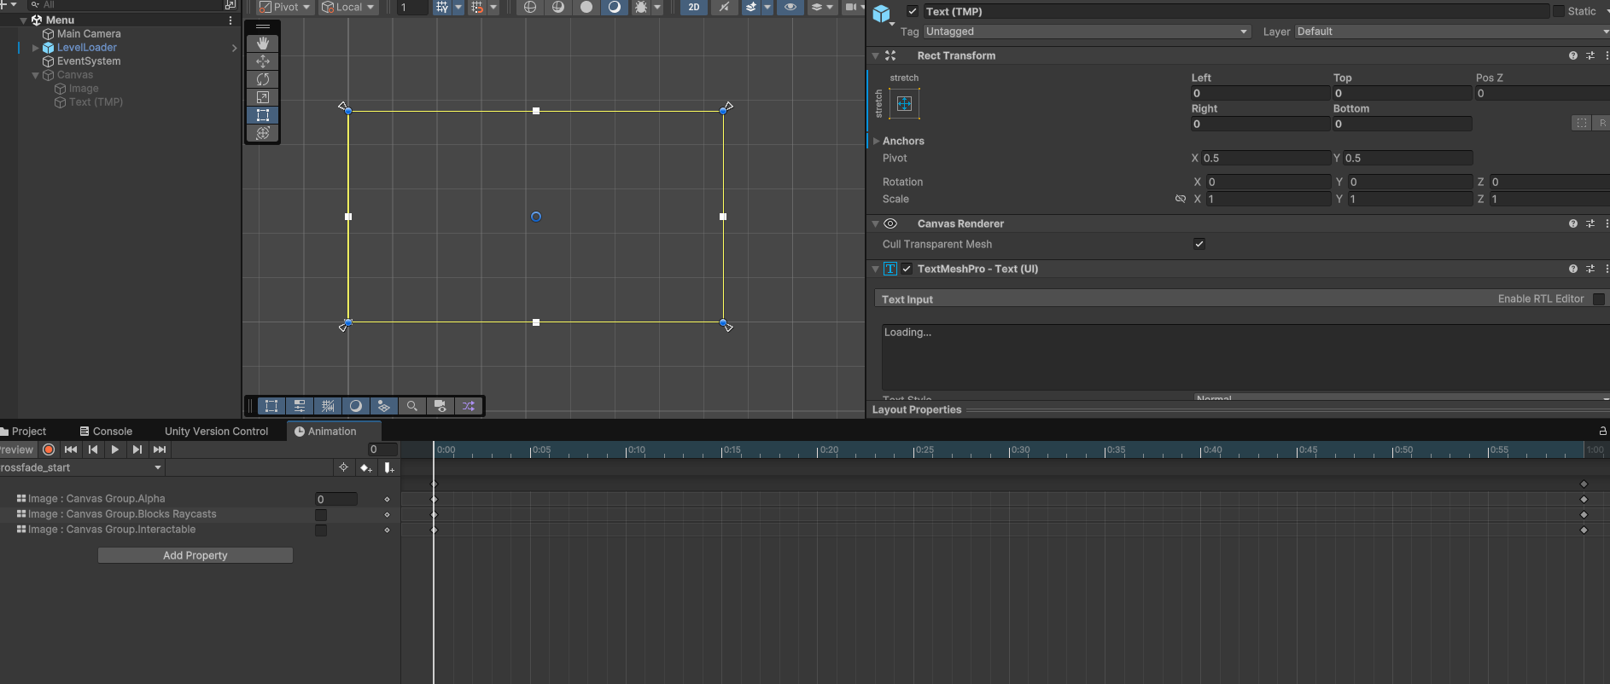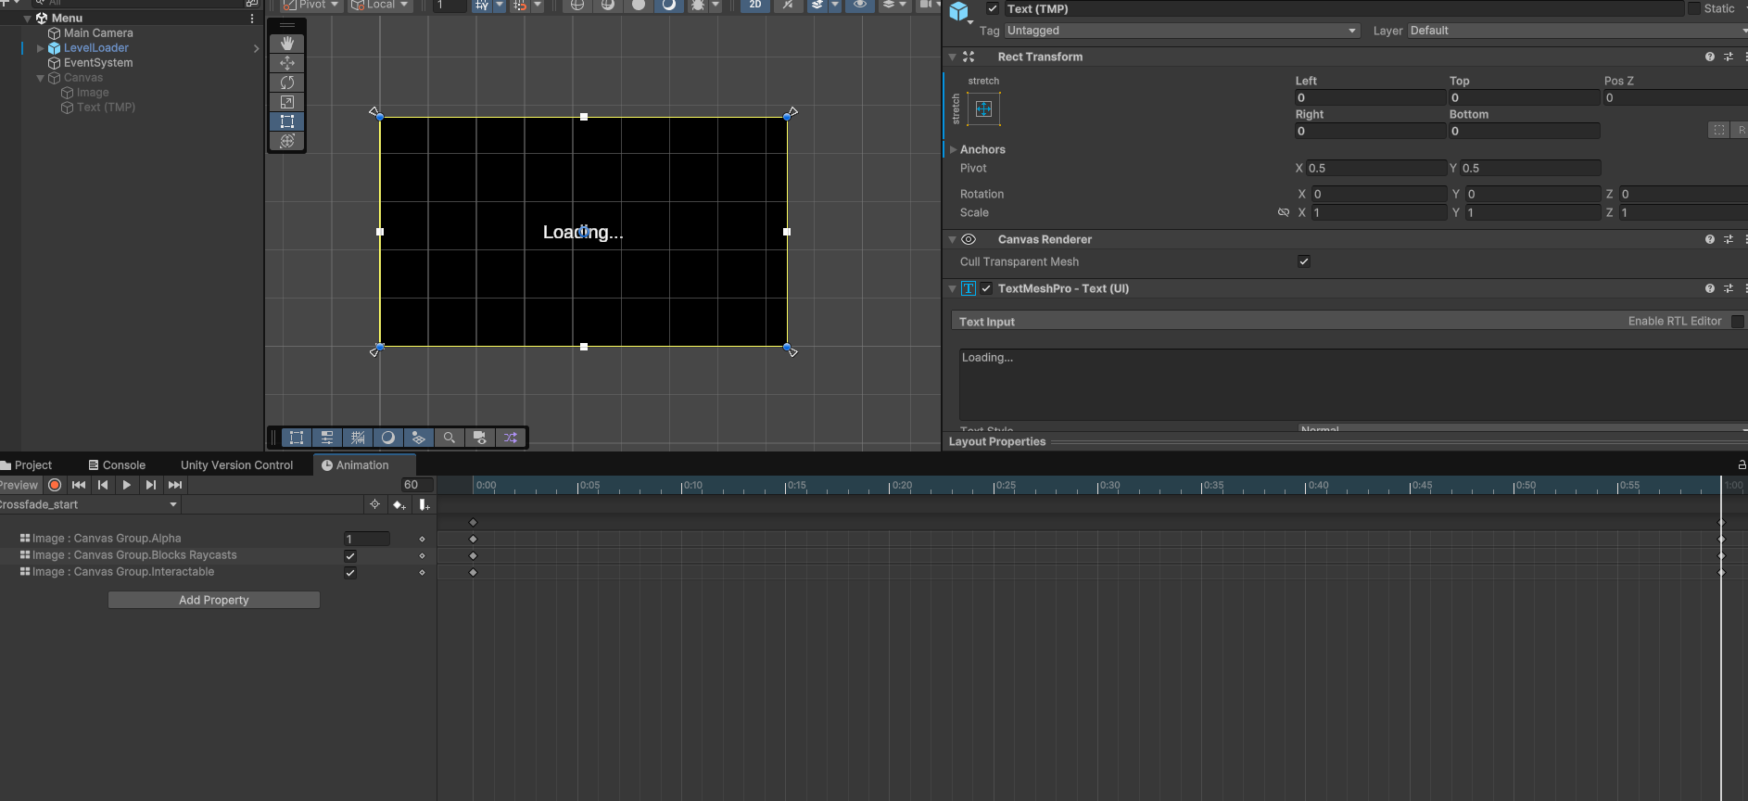

Now Test your game.